RESUME

Personal Details

Name |  | : | Ms. X.SHEENAKUTTY | 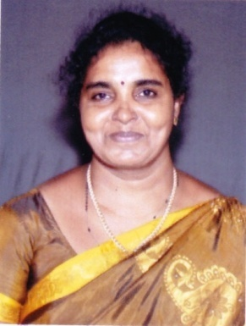
Father's Name |  | : | Mr. B. XAVIER
a. | Designation and Official Address | : | Assistant Professor  Department of Computer Science  U. D. College, Trichy– 19.
b. | Date of Appointment | : | 19. 06. 2024
c. | Residential Address | : | PLOT NO 7 MEENAKSHI NAGAR PRAKASH NAGAR EXTN,THIRUVERUMBUR,TRICHY  620013
d. | E-mail id | : | sheenakutty76@gmail.com
e. | Telephone/ Mobile No. | : | 9123552795/9486781023
Nationality |  | : | Indian
Sex |  | : | Female
Date of Birth |  | : | 01.01.1976
Languages Known |  | : | English, Malayalam, Tamil

Educational Qualifications

Institution & Place | Year of Passing | Degree Obtained | Class/Percentage
Sri Adhi Sankarar College of Education Trichy | 2012 | B.Ed | 78
Madurai Kamaraj University,  Madurai | 2007 | M.Phil  Computer Science | 64
Alagappachettiar College of Engineering And Technology Karaikudi | 2001 | MCA | 72
S.T.Hindu College Nagercoil | 1998 | M.Sc Physics | 60
St.Judes College Thoothoor | 1996 | B.Sc Physics | 69

Professional Experience

Period | No. of Years | Post Held | Name of the Institution
2003-2004 | 1.6 | Assistant Professor | Christu Raj College  Trichy
2004-2006 | 2.6 | P G Assistant | ST. Little Flower H.S.S Kattur
2006-2009 | 3.6 | Assistant Professor | Urumu Dhanalakshmi College Kattur
2013-2018 | 5.8 | P G Assistant | ST. Little Flower H.S.S Kattur
2022 | .8 | Assistant Professor | Dhanalakshmi Sreenivasan College for Women Perambalur
2023 | 1 | Assistant Professor | Bharath College Of Arts And Science Thanjavur
2024-till date |  | Assistant Professor | Urumu Dhanalakshmi College Kattur

TECHNICAL SKILLS
Operating Systems :Windows 2000, XP and 2007
Programming Languages: C, C++ ,Java, Python
Internet Technologies: HTML,XML, PHP
Others: MongoDB, Oracle, SQL, VB, Microprocessor Programming ,Digital Electronics

